📘 Project Documentation: Customer Credit Exposure via OData & ALV

1. Project Overview

- Objective: Build an end-to-end SAP mini project that exposes customer credit data via OData and consumes it in an ABAP report (ALV), simulating how Fiori or external applications would integrate.
- Flow:
Z-table → CDS View → OData Service → Gateway Client → ABAP Report (HTTP + JSON) → ALV Output

2. Backend Setup

Step 1: Create Custom Table
- Transaction: SE11
- Table Name: ZCUST_CREDIT
- Fields:
  - KUNNR (Customer ID)
  - NAME1 (Customer Name)
  - CREDITLIMIT (Credit Limit)
  - OPENORDERVALUE (Credit Used)
- Insert sample entries for demo customers.
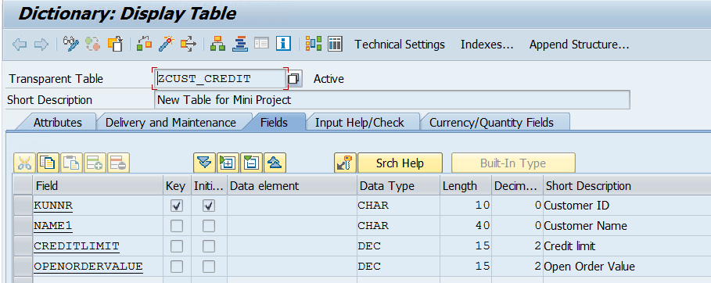

Step 2: Create CDS View

- Name: ZC_CustomerCreditExposure
- Purpose: Expose customer credit data with calculated field Availablecredit.
- Logic: Availablecredit = Creditlimit - Openordervalue.
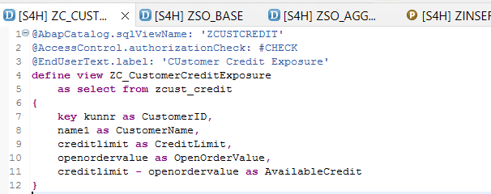

3. OData Service Exposure

Step 3: Register OData Service
- Transaction: SEGW (Gateway Builder).
- Service Name: ZGW_CUSTCREDIT_SRV.
- Entity Set: ZCUST_CREDITSet.
- Mapping: Map CDS fields (KUNNR, NAME1, etc.) to OData properties (Customerid, Customername, etc.).
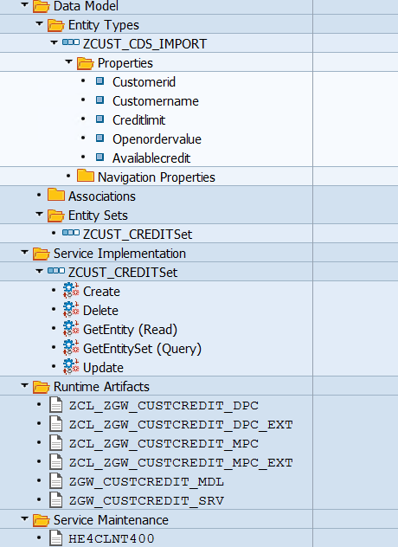

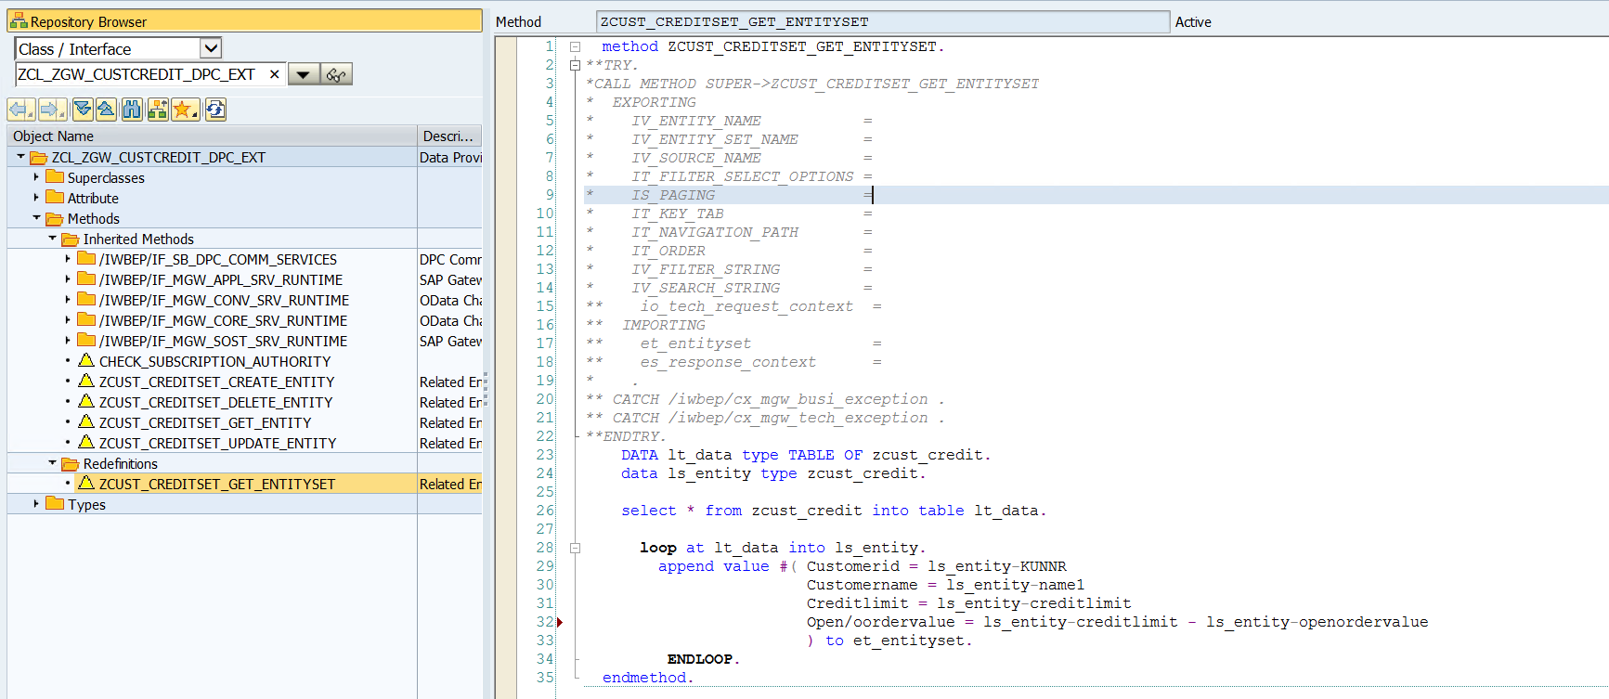

Step 4: Implement Business Logic
- In DPC Extension class, add calculation for Availablecredit.
- Ensure service returns calculated field along with raw data.

Step 5: Test in Gateway Client
- Transaction: /IWFND/GW_CLIENT.
- Test URL:
- /sap/opu/odata/sap/ZGW_CUSTCREDIT_SRV/ZCUST_CREDITSet?$format=json
- Verify response (JSON/XML) with customer data.
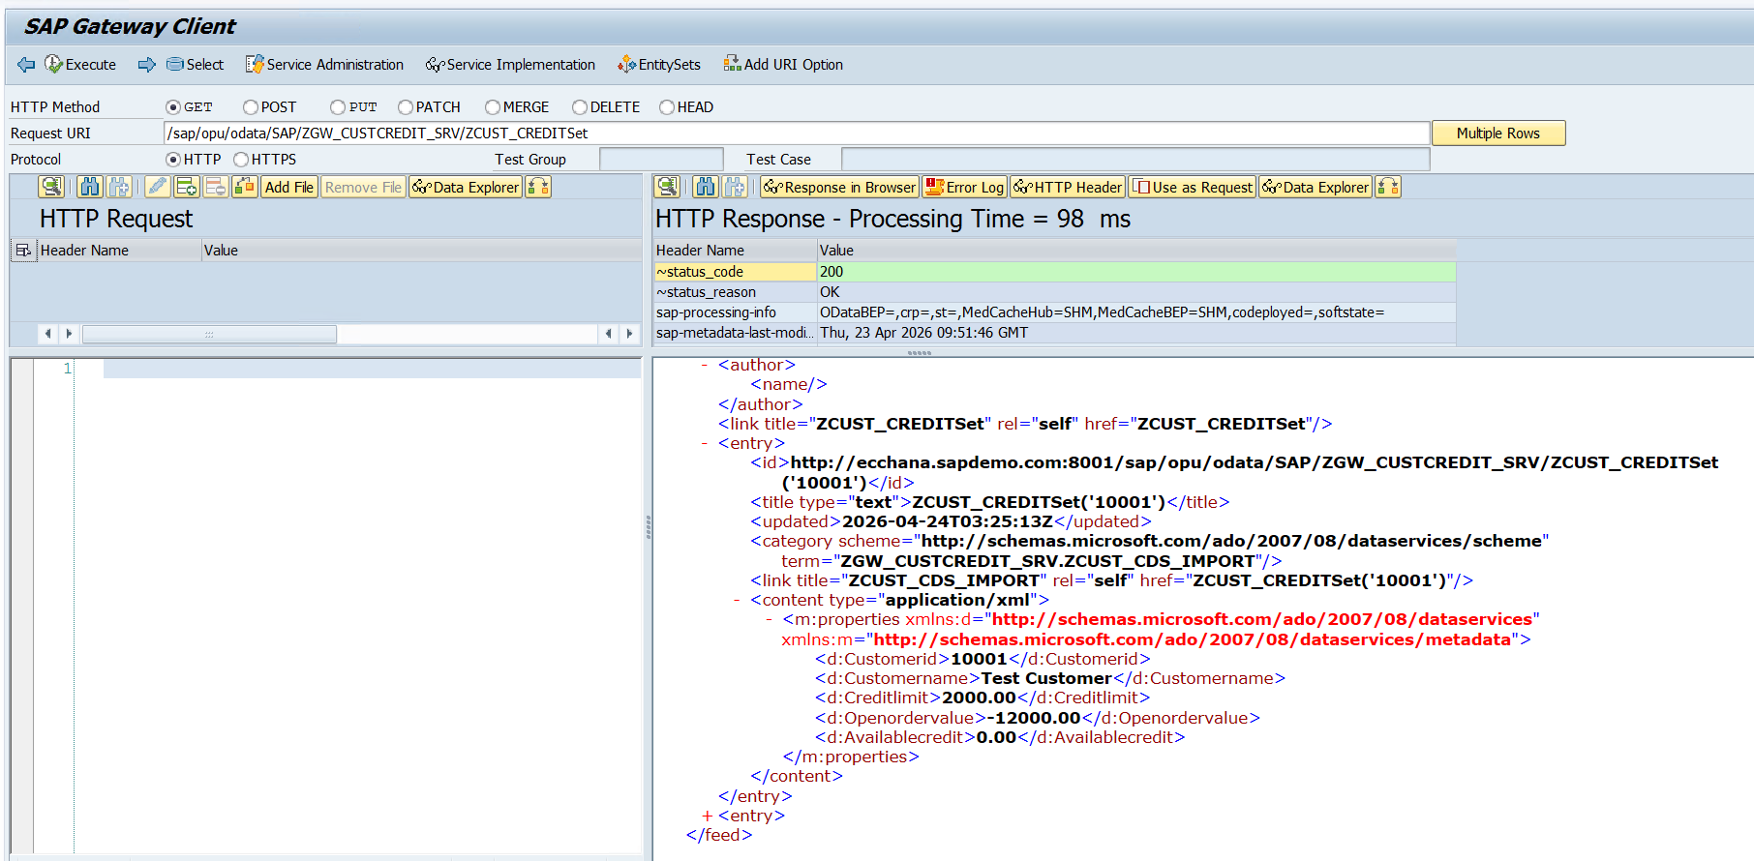

4. ABAP Report (Consumption Layer)

Step 6: Create Report Program
- Name: ZCUST_CREDIT_ALV_DEMO.
- Purpose: Consume OData service via HTTP client, parse JSON, and display in ALV.

Step 7: HTTP Client Setup
- Use CL_HTTP_CLIENT=>create_by_url with full HTTPS/HTTP link.
- Send GET request and receive response.

Step 8: JSON Parsing
- Use /UI2/CL_JSON=>deserialize.
- Handle nested structure (d.results).
- Map fields into local type ty_result.

Step 9: Business Logic
- Calculate Availablecredit = Creditlimit - Openordervalue in ABAP loop.

Step 10: ALV Display
- Use CL_SALV_TABLE.
- Optimize columns.
- Set business-friendly headers:
  - Customer ID
  - Customer Name
  - Credit Limit
  - Credit Used
  - Available Credit

5. Final Output
- ALV Grid showing customer credit exposure with calculated available credit.
- Data fetched directly from OData service link, not from backend table.
- Mimics Fiori app consumption.
Output: Via SE38 Report.
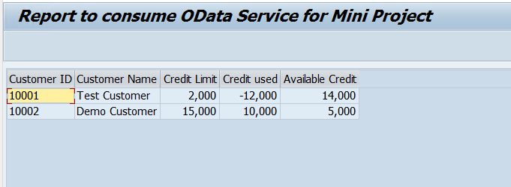
Output in CDS: here ‘OpenOrderValue’ is nothing but the ‘Credit used’.
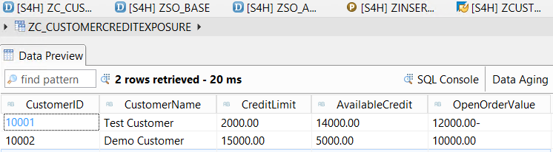

6. Key Learnings
- Difference between direct table access vs OData consumption.
- Importance of absolute URL and $format=json.
- Handling nested JSON structures (d.results).
- Using /UI2/CL_JSON for parsing.
- Professional ALV formatting for presentation-ready output.

